**LAB ASSIGNMENT #9**

**(a)**

**STATEMENT:** WRITE A PROGRAM TO FIND THE FACTORIAL OF ANY NUMBER USING RECURSION.

**SOURCE CODE:**

#include<stdio.h>

#include<conio.h>

long int fact(int n)

{

if(n==0)

return(1);

else

return(n*fact(n-1));

}

void main()

{

clrscr();

int n;

long int f;

printf("\n Input a number: ");

scanf("%d",&n);

f=fact(n);

printf("\n The factorial of %d = %ld",n,f);

getch();

}

**OUTPUT:**

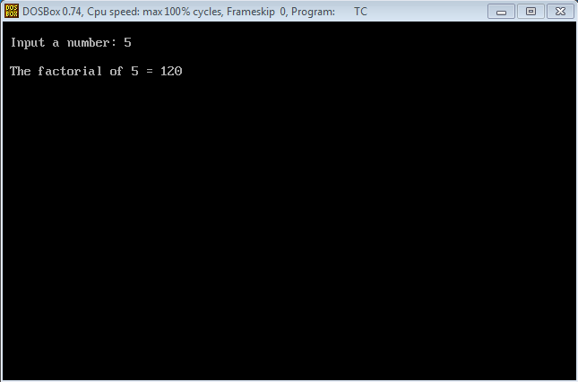

**CONCLUSION:**

Hence, the program was successful, and the factorial of any number was found using recursion.

**(b)**

**STATEMENT:** WRITE A PROGRAM TO FIND THE SUM OF NATURAL NUMBER USING RECURSION.

**SOURCE CODE:**

#include<stdio.h>

#include<conio.h>

long int sum(int n)

{

if(n==1)

return(1);

else

return(n+sum(n-1));

}

void main()

{

clrscr();

int n;

long int s;

printf("\n Input a number: ");

scanf("%d",&n);

s=sum(n);

printf("\n The sum of %d = %ld",n,s);

getch();

}

**OUTPUT:**

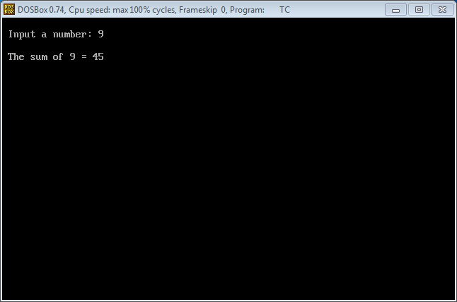

**CONCLUSION:**

Hence, the program was successful, and the sum of a natural number was found using recursion.

**(c)**

**STATEMENT:** WRITE A PROGRAM TO EVALUATE THE VALUE OF GIVEN EXPRESSION:

+A*BC

(WHERE, A=5, B=3 AND C=2)

**SOURCE CODE:**

**OUTPUT:**

**CONCLUSION:**

Hence, the program was successful, and the value of given expression: +A*BC was evaluated.